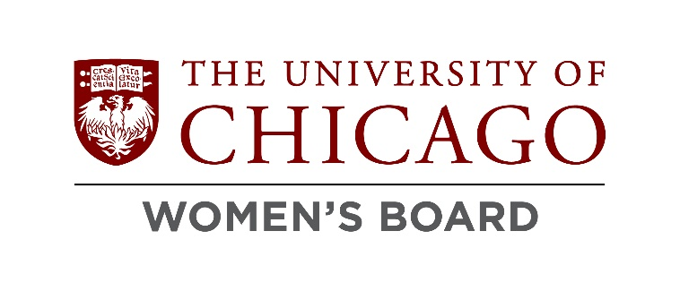

To All our Friends and Partners Throughout the University of Chicago Community,
The University of Chicago Women’s Board has been raising funds and supporting a diverse array of interests and work at the University for more than 60 years. Each year the UCWB raises funds from its membership and convenes a Grants Committee to make decisions on what the Board should support financially across the University. The Women’s Board takes pride in supporting grants from all divisions, schools, offices, and units within the University community. The primary requirement of all proposals is that they must reflect and bolster the core values of the University of Chicago.
As we find ourselves fully emerged from the pandemic, with new leadership and a committed staff, we are reimagining our grant-making process. Our hope is to better engage our full membership in the process of deciding what campus-needs are most compelling and what projects and ideas are most exciting to our members. Additionally, we wish to invite the broadest range of requests to apply for this funding. The Board will select proposals in four key areas, all of which are equally important to the mission of the University of Chicago Women’s Board.
- proposals supporting faculty research and support
- proposals funding the arts and cultural institutions
- proposals aimed and raising the quality of student life
- proposals supporting the University as it increases its outreach to and support of the community that surrounds our campus.
To allow for a broad range of applicants, to create a decision process that includes all of our members, and to better respect and honor the large number of demands on the time of university faculty, students and community members, our proposal process will now start with a short form Letter of Intent (LOI). Other than contact information and your requested grant amount, all we would like from first round proposers is a few sentences about why you are seeking a grant from the UCWB. Consider this an “elevator pitch.” Our hope is to first determine what ideas most appeal to the Women’s Board members and then ask a smaller group of grant seekers to invest their time and effort to submit a full proposal, which will then be considered by a dedicated Grants Committee. We imagine some of you will have questions about this process and we invite your inquiries as we rework our grant making process. Thank you from the entire University of Chicago Women’s Board and we look forward to your grant ideas!

Sincerely,

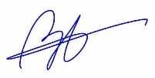

Brigitte Ozzello
Director, University of Chicago Women’s Board
bozzello@uchicago.edu
(773) 702-9322

LETTER OF INTENT FORM FOR GRANT APPLICANTS
2024-2025 Academic Year

Dear Potential University of Chicago Women’s Board 2024 Grant Recipients,
In order to make sure that we are soliciting the grant proposals that our organization wishes to consider, and to alleviate the burden of having grant seekers assemble proposals that are less likely to be funded, we ask that you provide us with the following information as a “letter of intent” to propose a grant for funding. The Women’s Board plans to choose a smaller field of possible recipients from this group, approximately 20, who will then be asked to submit a more in-depth proposal.

- GRANT REQUEST MADE BY:
1a. Name: (Your answer)
1b. Title: (Your answer)
1c. Email: (Your answer)
1d. Phone: (Your answer)

- DESCRIBE YOUR PROPOSAL:

2a. Grant Title: (Your answer)

2b. Requested Amount: (Your answer)
Please note that the greatest possible grant available is $100,000 and that most grants average around $40,000.

2c. Please indicate in which of the following categories your proposal belongs.
Check only one.
  - Faculty Research
  - Arts and Culture
  - Student Life
  - Community Outreach

2d. PLEASE EXPLAIN HOW YOU INTEND TO USE YOUR GRANT IN 125 WORDS OR LESS.
This should be in the form of an “elevator pitch.” Please focus on the “why” of your project or grant, rather than its process or feasibility.
Please note that these short explanations are intended to serve as statements of intent, and all statements will be shared with entirety of the University of Chicago Women’s Board membership to allow them to indicate for which potential grants they would like to see full proposals.

(Your answer – 125 words or less)

3. SUBMIT

When complete, please submit this form via email to UCWB@uchicago.edu.
All submissions are due by 5:00pm on Friday, February 9, 2024.

You will be notified by Friday, March 15th if you have been selected to submit a full grant proposal. All full grant proposals will be due by Friday, April 26, 2024.
Note that the application for the full proposal will be available by January 26th.
If you have any questions, please contact Brigitte Ozzello, bozzello@uchicago.edu or
(773) 702-9332.

